**Joseph Tierney**

**Computer Science 2**

**Windows Programming**

**Programming Controls Assignment**

**Introduction**

This assignment will demonstrate accessing how to read and write from files. In order to access the student management system, a user will be required to log into the program from the Login form. The login form will require the user to enter the correct username (admin) and password (password) to be able to access the student management form. The student management form will hold five entries by default, and users will be able to edit the details, add new entries, search current entries, and delete existing ones. Validation is carried throughout to program.

**Initial Design**

The student management system is separated into two forms. The first form for the programme is a Login form, and the second form is the Student Management System form.

**Form1 – Login Form**

The login form was designed with the user in mind. It requires the user to enter the correct username and password to open the student management form if the login details are valid.

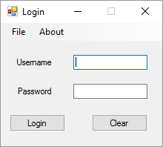

The user is able to end the program by clicking either the X in the top right or by selecting File > Exit. Both methods will show a messagebox letting the user know that the program is ending. This was added to ensure that the user knows they have ended the program and it wasn’t done by an error. Selecting Help > About will show the user another messagebox, this time informing them on who created the program.

Clicking the Clear button will clear out the text fields for Username and Password, and will then focus on the Username textbox. Clicking Login will log the user in, but only if they have entered the correct login details. The login details entered will be checked against the ones that are assigned in Visual Basic. The username is “admin” and the password is “password”.

While designing the login form, I made it so that the user will not be able to minimize, enlarge or change the size of the form, this was done to ensure that everything looks easy on the eye and professional. Username and Password are labels, with text boxes beside them. When the user doesn’t enter a username or password, they are shown a messagebox informing them. This also happens when the user enters a wrong username or password. In the password textbox, when entering the password *’s will appear instead of normal characters, this was done for security and to look professional – as most login forms use *’s for password characters.

**Student Management Form**

The user is able to end the program by clicking either the X in the top right or by selecting File > Exit. Both methods will show let the user know that the text file has been updated upon exiting, this was done in case the user quits without saving .The user will also not be able to enlarge or change the size of the form. Selecting File > Save will save whatever changes the user has made to the document. The Edit toolbar features allow the user to Add a new student, Edit a current student, delete the student they are currently on, show the students who have passed and show the students who have failed. The Search feature will allow the user to search for a current record in the text file by input box.

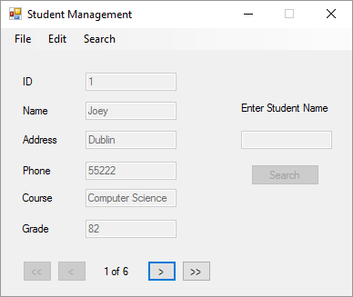

Underneath the menu tool strip are the textboxes used for editing the details of a currently existing entry or adding a new one. They are disabled until the user clicks the Edit Student or Add Student under the menu tool strip, this was done in order to avoid accidental edits. While on the first record, the First and Previous buttons are disabled, this was done because the array does not go back that far and while the user is on the last record, the Next and Last buttons are disabled, this was done because the array does not go past the number of records which currently exist. The position label automatically updates when the user clicks the navigation buttons.

The validation which takes place checks if the name textbox is blank, if the address textbox is blank, if the phone textbox is blank or not numeric, if the course textbox is blank and if the grade textbox is blank or not numeric. When there is an invalid entry, a messagebox along with a beep will occur informing the user of which one they need to change.

When clicking the Edit Student button or Add Student button in the menu tool strip, the tool strip is disabled (for Edit Student only) and the Previous, First, Last and Next buttons are hidden in order to prevent the user from selecting any other options until they click Save or Cancel. When the Edit Student button or Add Student button are clicked, Previous, First, Last and Next buttons will be hidden from view and the Save and Cancel buttons will be shown. The name, address, phone, course and grade text boxes will all be enabled to allow the user to edit or add an entry, the ID text box will remain disabled as this is updated automatically for the user. The Search button and text box are both disabled until the user clicks on Search in the menu tool strip.

**Program Walkthrough**



The program begins with the login screen being displayed.

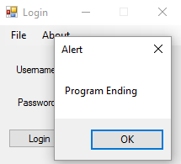

Selecting File > Exit (or clicking X) will end the program, and shows the user a messagebox before the program ends.

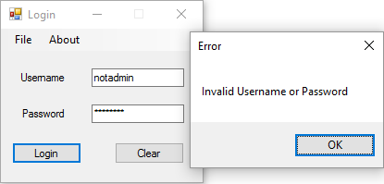

When the user enters an invalid username or password they are shown a messagebox informing them that the information entered was invalid.

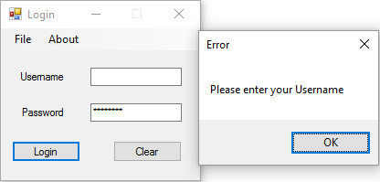

Leaving the username textbox blank will show the user a messagebox asking them to enter a username. When the user clicks OK, the cursor is focused on the username text box.

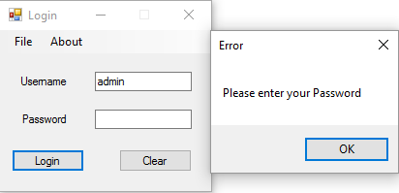

Leaving the password text box blank will show the user a message box asking them to enter a password. When the user clicks OK, the cursor is focused on the password text box.



When the user clicks the Clear button, both textboxes will be reset and will focus on the username textbox.

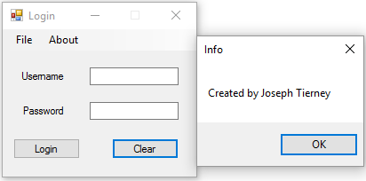

When the user clicks About, a message box will be displayed showing the user who created the program.

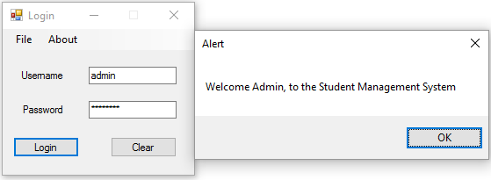

When the user enters the right login details and selects Login, they are welcomed to the program with a message box. Once they click OK, the login form hides and they are logged into the Student Management System.



As the user is logged in, the student management form is displayed with the first record in the system and First and Previous buttons disabled.

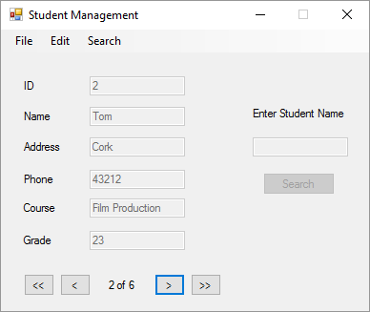

Clicking the Next button will display the next record in the system. The positon of the record will atomically update as the buttons are clicked.

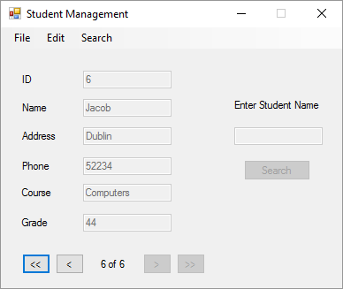

Clicking the Last button will display the last record in the system and will also disable the Next and Last buttons. The positon of the record will atomically update as the buttons are clicked.

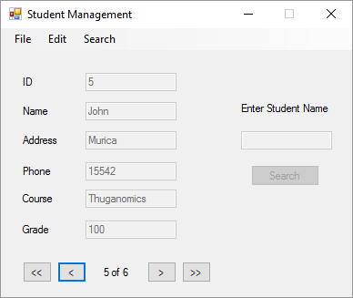

Clicking the Previous button will display the previous record in the system. The positon of the record will atomically update as the buttons are clicked.



Clicking the First button will display the first record in the system. The positon of the record will atomically update as the buttons are clicked.

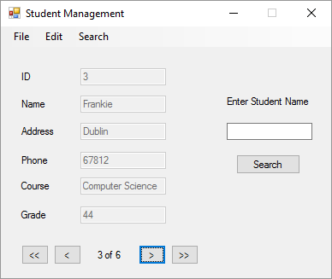

When the user clicks Search, the search text box and Search button are enabled. This will allow the user to search for a specific student in the system.

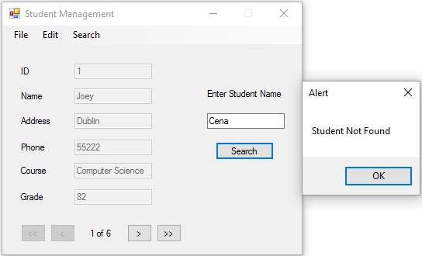

If they enter a student who is not in the system, a message box will tell them that the student was not found.

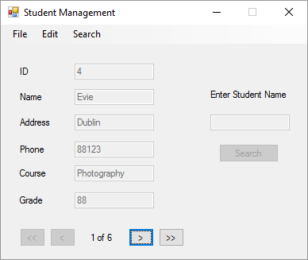

When the user enters the name of a student who is in the system, the text boxes will update with their details and the search button and text box will be disabled.

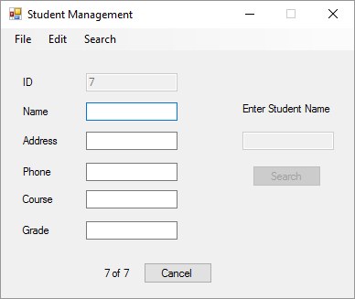

Selecting Add New Student will create a new record, and will enable the Name, Address, Phone, Course and Grade text boxes to be edited. It will also hide the First, Previous, Next and Last Buttons and display a cancel. The user must save through the File menu.

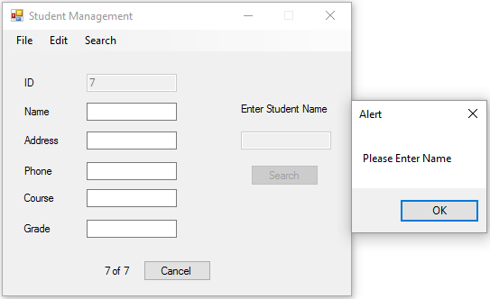

If the user tries to save without entering any information, they are told to enter a name. The cursor will then focus on the name text box.

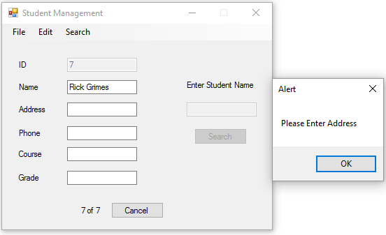

If the user tries to save without entering information for an address, they are told to enter an address. The cursor will then focus on the address text box.

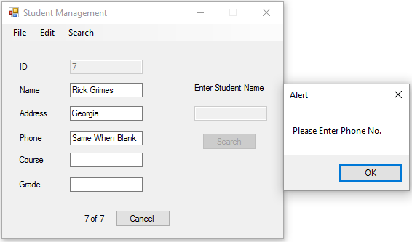

If the user tries to save without entering information for a Phone Number or enters letters instead of numbers, they are told to enter a Phone number. The cursor will then focus on the phone text box.

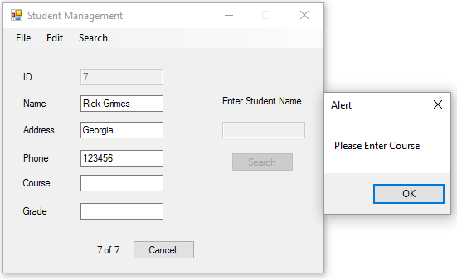

If the user tries to save without entering information for a course, they are told to enter a course. The cursor will then focus on the course text box.

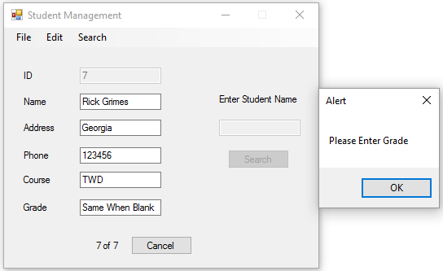

If the user tries to save without entering information for a Grade or enters letters instead of numbers, they are told to enter a Grade number. The cursor will then focus on the grade text box.

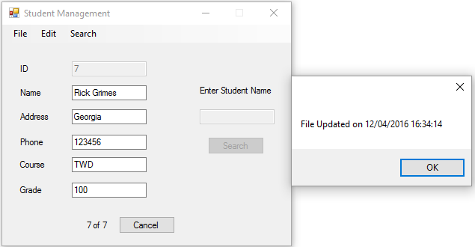

When all the details for the new student have been entered correctly and when the user hits save, the file is updated.

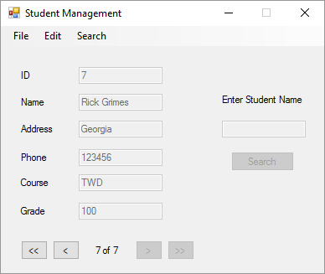

The new entry is then added to the system and the positions are updated.

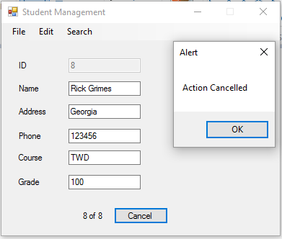

If the user adds a new entry and clicks cancel, the text boxes are reset and a message box will appear telling them that the action was cancelled, and the previous record will be displayed.

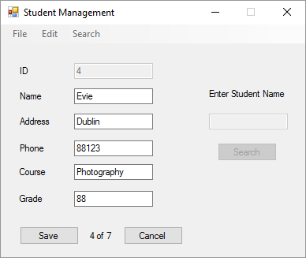

When the user chooses to edit a student, the First, Previous, Next and Last buttons will be hidden and the save and cancel buttons will be shown. The menu tool strip will also be disabled while editing a record.

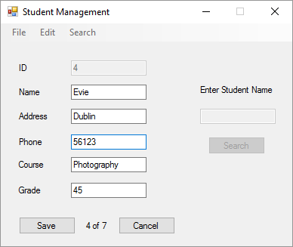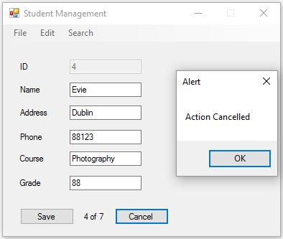

If the user hits cancel, the record will revert back to its last saved state and a message box will tell the user that their action has been cancelled. When the user clicks OK, the Save and Cancel buttons will be hidden and the First, Previous, Next and Last buttons will be shown. The menu tool strip will also be enabled.

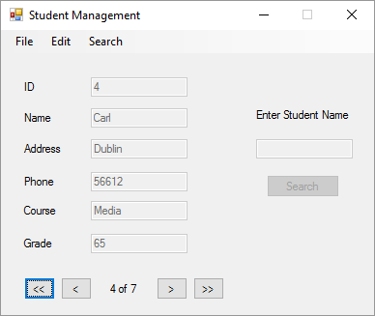

While editing, clicking save will update the record with its new values entered in by the user.

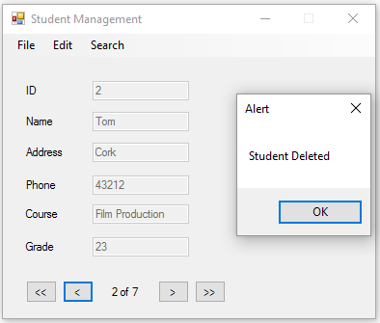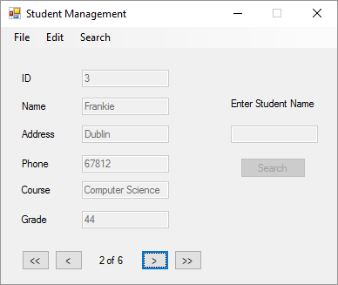

When the user selects Delete Student from the menu tool bar, a message box will inform them that they have deleted the student they are currently on. When the user clicks either of the navigation buttons below, the system will update and replace the deleted student. The positions will also automatically update.

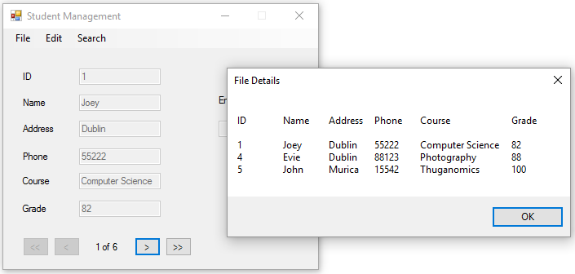

When the user selects Show Passes from the menu tool bar, a message box will be displayed displaying all the details of the students who have an overall grade equal to or above 50.

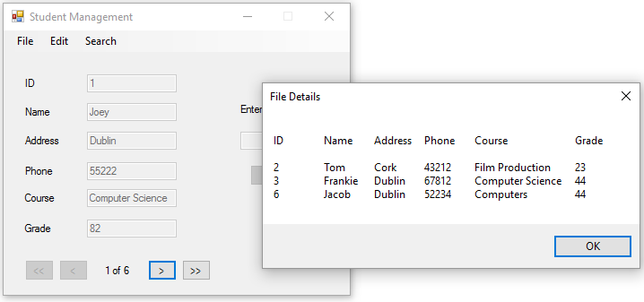

When the user selects Show Fails from the menu tool bar, a message box will be displayed displaying all the details of the students who have an overall grade equal to or less than 49.

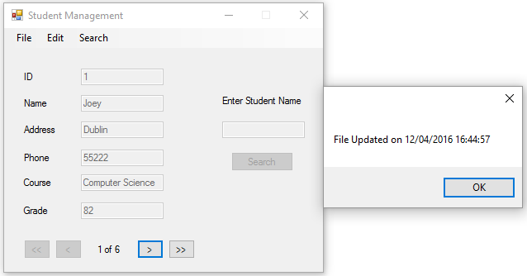

Selecting File > Save will save the system in its current state. While selecting File > Exit or clicking the X will end the program and save the system in its current state too.

**Test Bed**

|  |  |
| --- | --- |
| Action | Result |
| Login Form | |
| Login Button | |
| Empty Username textbox entry | Beep. Messagebox: “Please Enter Username”  Focus on Username textbox |
| Empty Password textbox entry | Beep. Messagebox: “Please Enter Password”  Focus on Password textbox |
| Invalid Username or Password | Beep. Messagebox: “Invalid username or password”  Focus on Username textbox |
| Valid Username and Password | Messagebox: “Welcome Admin to the Student Management System”. Hide login form and show student management form |
| Clear Button | |
| Any values in either textbox | Clear both textboxes. Focus on Username textbox |
| File > Exit and ‘X’ | |
| Any values in either textbox | Beep. Messagebox. “Program Ending”  Program ends |
| Help > About | |
| Any values in either textbox | Messagebox: “Created by Joseph Tierney” |
| Student Management Form | |
| Move first | Moves student selection to first entry |
| Move previous | Moves student selection to previous entry |
| Move next | Moves student selection to next entry |
| Move last | Moves student selection to last entry |
| Delete student | Beep. Messagebox: “Entry deleted”. Entry removed from system |
| Add new student | Adds new entry to system |
| Show passes | Message box: Students who scored above 50% |
| Show fails | Message box: Students who scored below 50% |
| Search | Displays student entries whose name field matches the text entered in the search name textbox |
| Save | Saves the system in its current state and updates the text file |
| Edit Student | Allows the user to edit the name, balance and overdraft fields of the currently selected database entry. Replaces Edit Details button with Done and Cancel buttons. |
| Empty Name text box entry | Beep. Messagebox “Please enter Name” Focus on Name Text Box |
| Empty Address text box entry | Beep. Messagebox “Please enter Address” Focus on Address Text Box |
| Empty Phone text box entry | Beep. Messagebox “Please Enter Phone No.” Focus on Phone Text Box |
| Letters in Phone text box entry | Beep. Messagebox “Please Enter Phone No.” Focus on Phone Text Box |
| Empty Course text box entry | Beep. Messagebox “Please Enter Course” Focus on Course Text Box |
| Empty Grade text box entry | Beep. Messagebox “Please Enter Grade” Focus on Grade Text Box |
| Letters in Grade text box entry | Beep. Messagebox “Please Enter Grade” Focus on Grade Text Box |
| Empty Search text box entry | Beep. Messagebox “Please Enter Student Name” Focus on Search Text Box |
| No existing student in search text box | Beep. Messagebox “Student not Found” |
| File > Save | |
| Any values in either text boxes and any state | Saves the system in its current state and updates the text file |
| File > Exit or ‘X’ | |
| Any values in either text boxes and any state | Saves the system in its current state, updates the text file and ends the program |

**Conclusion**

Overall, the program works as intended and the test bed results match with the expected outcomes. Problems early on in the assignment included setting the Cancel button on the student management form to reset itself to the last save state it was in, however this was fixed later on by adding the temporary variables. When using the search feature, the position label will not update to the where the record is and instead acts as if it’s on the first record until the user clicks Next. To improve on this program if I had more time, I would add a counter that would save the file automatically after every 60 seconds.